
  Stonefield Surgery
  Milnrow & Newhey Medical Centre
  Newhey Road, Milnrow
  Rochdale
  OL16 4JQ
Patient Participation Group

MINUTES of PPG Meeting held on Wednesday 18th February 2026 @ 4.30pm.

Attendees: Apologies:
Neil Butterworth (Acting Chair) Brian McGill (Chairman)
June Ghilene (secretary) Kay Harrison
Barry Sanderson
Karen Black
Liz Brookes

 | Discussion Item | Action/Resp
1 | Review of previous minutes  Minutes of previous meeting passed as true record by Neil Butterworth Seconded by June Ghilene. | Fact
2. | New Member & Resignations  Jacqui Mellor – Resignation due to meetings clashing with her carers work.  If her circumstances change, she may return.  Karen Kelland – Resignation due to moving house and too far to come for meetings.  We thank them both for the support and wish them well.  New Member  Liz Brookes - We welcomed Liz who is a returning member to the PPG. | Fact
3. | New Agenda  Going forward, June felt that the Agenda needs a new structure as it has become very repetitive. Neil stated that we need to concentrate on measurements and focus on topics to be improved to be added to next Agenda. | Fact
4 | DNA’S – Patients who ‘Did Not Attend’ their appointment.  2025 - March 154 / April 125 / May 142 / June 164 / July 160 / Aug 140 / Sept 179 /  Oct 253 / Nov 160 / Dec 136.  2026 – Jan 170 / Feb 162  YOY comparison (as per graph below)  It was agreed that at the next meeting the topic should be brainstorming DNA’s and how we can improve. | Fact
5  6 | Friends & Family Results  Will be Topic of the month for next meeting  Jan 2026 – 17% Response Rate / 1370 Appointments = 229 responses from patients  Dec 2025 – 17% Response Rate / 1200 Appointments / 208 responses from patients  Nov 2025 – 18% Response Rate / 1274 Appointments / 232 responses from patients  Registered Patients  Patient registrations continue to grow.  There is a new development near Broad Lane 60 dwellings. Karen offered to drop some leaflets off to the show home. June will speak to Practice Manager and advise Karen. | Fact  June/  Jo Lees
7 | Google Reviews  We are working together with Primary Care Growth Strategies to improve our rating for Google reviews. Since working with them, our reviews have massively increased in the last few months with us receiving 628 reviews 4.8 star mostly 5* reviews.    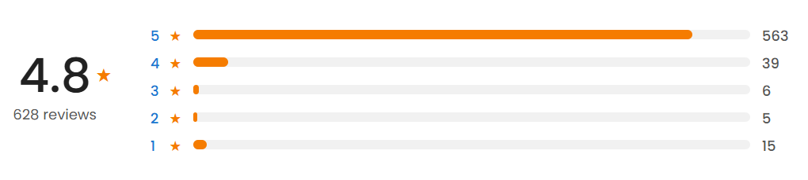  We send a text message out to all patients daily who have had an appointment that day to encourage them to respond with a google review.
5 | Practice Update  Videos on Facebook of the GPs doing talks on various subjects to improve patients health journey. Please watch and comment or like.  - Patchs by Dr U Ahmed  - Worried about a cough by Dr Linton  - Walk-in X-Ray Dept by Dr Linton  - PSA Tests (Prostate) by Dr Linton  - UTI’s by Dr Crowley  - HRT by Dr Crowley  - Menopause by Dr Crowley  - Contraception by Dr Crowley  - Blood Pressure Symptoms by Dr Linton  - Being a Carer by Dr Linton  - Friends & Family Feedback by Dr U Ahmed
6 | A.O.B  Liz Brookes asked if the practice will be doing anything for World Delirium Awareness Day 11th March. This annual event aims to raise awareness about delirium and its impact on patients, families and healthcare systems. It is intended to bring attention to the importance of early recognition and intervention of delirium, and to raise awareness of the latest research, guidelines, and best practices in the field  There is a Webinar hosted by Professor Emma Vardy on 11th March.  Liz to send June a link who will design a poster to put up in the practice and on the waiting room screens. | Liz Brookes

2026 Meeting Dates @ 4.30pm
Wednesday 18 February 2026
Wednesday 15 April 2026
Wednesday 17 June 2026
Wednesday 19 August 2026
Wednesday 21 October 2026
Wednesday 16 December 2026 (Christmas party)

