
  Stonefield Surgery
  Milnrow & Newhey Medical Centre
  Newhey Road, Milnrow
  Rochdale
  OL16 4JQ
Patient Participation Group

MINUTES of PPG Meeting held on Wednesday 15th April 2026 @ 4.30pm.

Attendees: Apologies:
Brian McGill (Chairman) Jo Lees (Practice Manager) Karen Black
June Ghilene (secretary) Dr Sarah Crowley Liz Brookes
Neil Butterworth
Kay Harrison
Barry Sanderson

 | Discussion Item | Action/Resp
1 | Review of previous minutes  Minutes of previous meeting passed as true record by Neil seconded by Barry. | Fact
2 | DNA’S – Patients who ‘Did Not Attend’ their appointment.  2025 - March 154 / April 125 / May 142 / June 164 / July 160 / Aug 140 / Sept 179 /  Oct 253 / Nov 160 / Dec 136.  2026 – Jan 170 / Feb 162 / 152  YOY comparison (as per graph below)  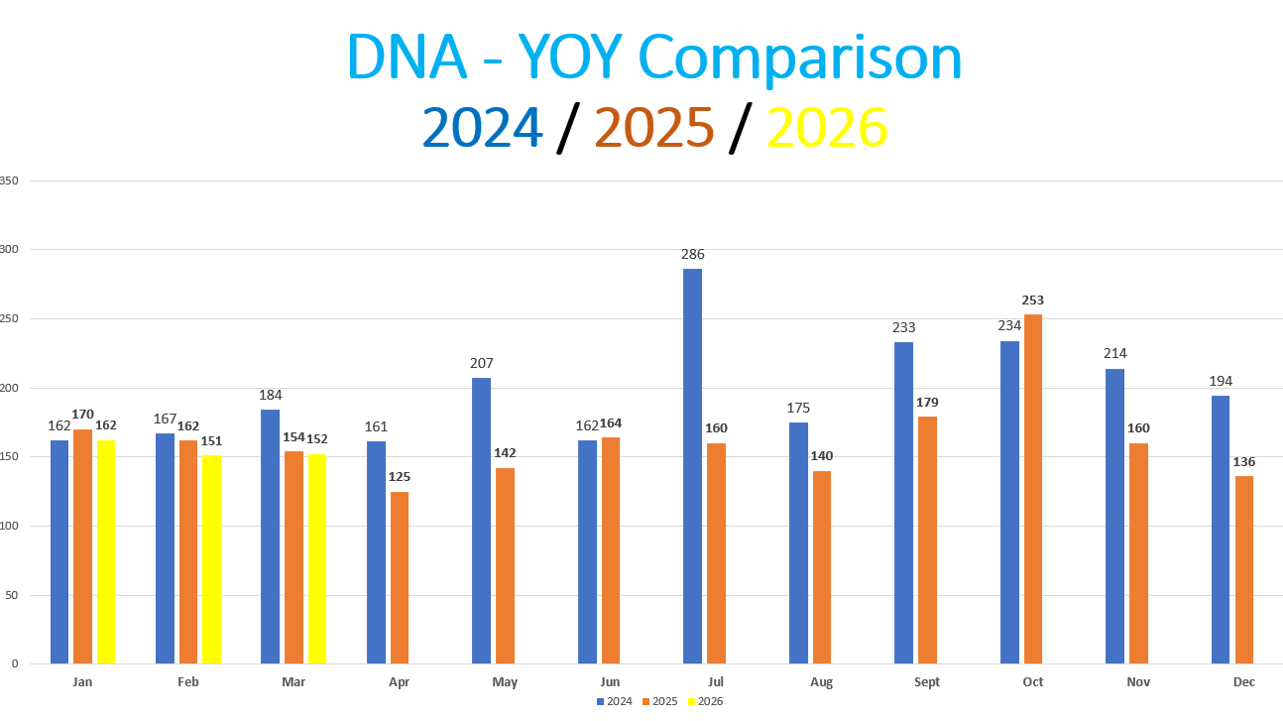 | Fact
3  4  6 | Friends & Family Results  Mar 2026 – 18% Response Rate / 1206 Appointments = 220 responses from patients  Feb 2026 – 16% Response Rate / 1052 Appointments = 165 responses from patients  Jan 2026 – 17% Response Rate / 1370 Appointments = 229 responses from patients  Registered Patients
7 | Google Reviews  We are working together with Primary Care Growth Strategies to improve our rating for Google reviews. Since working with them, our reviews have massively increased in the last few months with us receiving 519 reviews 4.8 star mostly 5* reviews.    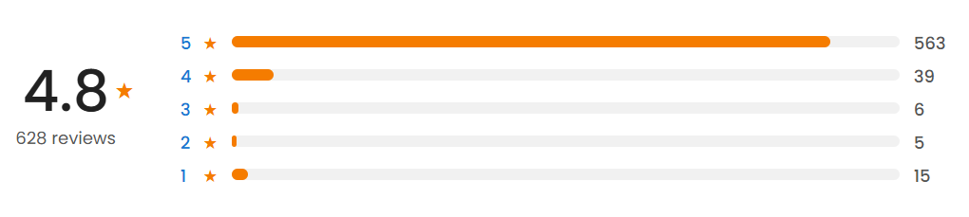  We send a text message out to all patients daily who have had an appointment that day to encourage them to respond with a google review.  Text messages sent:
5 | Practice Update  New SmartNav system – launched 15th April  Jo Lees – Practice Manager explained the new system when patients call the surgery which will enable the staff to be able to triage the patients to ensure they are seeing the correct person first time rather than waste the appt and have to re-book.  There were teething problems, but the system is being monitored and can be tweaked to what we required and will be reviewed, and results will be shared at the next PPG meeting in June.  The surgery is also looking at a new phone system, either an upgrade to current system or a new system which will identify a patient ringing from the phone number they are ringing from, and their name will show up.  If a patient comes to the desk to book and their issue is private, they can ask for a slip to write it down and pass to the receptionist or be taken into a private room to discuss their problem.  Extended Access  The surgery now has extended access until 8pm on Mondays for Milnrow Village and Tuesdays for Stonefield Surgery for our patients and Littleborough Practice.  Patchs  Is changing to a new system called Accurx but will be renamed which is much better than Patchs – more info to follow shortly. (Don’t panic Neil, you will love it!!)  Facebook Videos  Videos on Facebook of the GPs doing talks on various subjects to improve patients’ health journey. Please watch and comment or like. We are receiving great reviews from patients about the videos on Facebook.  - Patchs by Dr U Ahmed  - Worried about a cough by Dr Linton  - Walk-in X-Ray Dept by Dr Linton  - PSA Tests (Prostate) by Dr Linton  - UTI’s by Dr Crowley  - HRT by Dr Crowley  - Menopause by Dr Crowley  - Contraception by Dr Crowley  - Blood Pressure Symptoms by Dr Linton  - Being a Carer by Dr Linton  - Friends & Family Feedback by Dr U Ahmed | Fact
6 | A.O.B  - Brainstorming DNAs moved to next meeting 17th June. JG to put on Agenda | June

2026 Meeting Dates @ 4.30pm
Wednesday 18 February 2026
Wednesday 15 April 2026
Wednesday 17 June 2026
Wednesday 19 August 2026
Wednesday 21 October 2026
Wednesday 16 December 2026 (Christmas party)

