
  Stonefield Surgery
  Milnrow & Newhey Medical Centre
  Newhey Road, Milnrow
  Rochdale
  OL16 4JQ
Patient Participation Group

MINUTES of PPG Meeting held on Wednesday 17th June 2026 @ 4.30pm

Attendees: Apologies:
June Ghilene (PPG Secretary) Brian McGill (Chairman)
Karen Black Neil Butterworth
Kay Harrison Barry Sanderson
Liz Brookes
Jo Lees (Practice Manager)
Dr Sarah Crowley

 | Discussion Item | Action/Resp
1 | Review of previous minutes  Minutes of previous meeting passed as true record | Fact
2 | Healthwatch Rochdale  Presentation by Naomi Burke - Engagement and Volunteer Manager.  Healthwatch Rochdale is a local health and social care champion to ensure that NHS leaders and decision-makers hear patients voices and use their feedback to improve care. Also they help patients to find reliable and trustworthy information and advice.  Brochures to circulate at next meeting for those members who were not in attendance at this meeting.  Naomi shared a Patient Feed report which showed positive results. (see copy below) They will share information on a recruitment drive and how to encourage more patients to join our PPG. e.g. attach a PPG slip to Pharmacy Bags with meeting dates.  Healthwatch will send email to June. | Fact
3 | Practice Update  Given by Jo Lees (Practice Manager and Dr Sarah Crowley)  - Online access is changing from Patchs to Accurx which is much better. The form is straight forward, actioned in the same way and is much quicker. Patients will be advised by the practice of the changeover.  - Flu vaccines will have a link, so patients do not have to phone for an appointment.  - Abtrace - Another new system will be introduced called Abtrace which will automatically send patients a message when their regular Reviews are due, i.e. hypertension, health checks etc. saving time for staff having to ring or message patients to attend for their Review.  - Phones – a new phone system will be introduced shortly with many benefits for patients and staff. More details to follow in due course once launched.  - Staffing – we have 3 nurses currently attending University on day release. 2 with open university and 1 at Salford. All will bring great benefits for the practice once complete. We have Katie (Locum cover) to cover the backfill, so no appointment slots are lost.  - Extended Access – the practice now offers Tuesday evening extended access 6.30pm – 8pm and alternative Saturdays. Appointments are available to see a GP, Nurse or Health Care Assistant and can book a Spirometry, an Echo Cardiogram, etc.
4 | DNA’S – Patients who ‘Did Not Attend’ their appointment.  YOY comparison (as per graph below) | Fact
5  6 | Friends & Family Results  May 2026 – 15% Response Rate / 1204 Appointments = 177 responses from patients  April 2026 - 18% Response Rate / 1171 Appointments = 216 responses from patients  Mar 2026 – 18% Response Rate / 1206 Appointments = 220 responses from patients  Registered Patients
7 | Google Reviews  We are working together with Primary Care Growth Strategies to improve our rating for Google reviews. Since working with them, our reviews have massively increased receiving 527 reviews 4.8 star mostly 5* reviews.    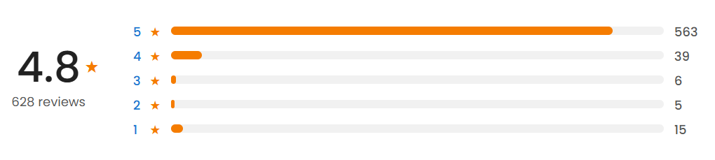  We send a text message out to all patients daily who have had an appointment that day to encourage them to respond with a google review.  Text messages sent per day:
8 | A.O.B  - Liz Brookes expressed an interest in taking part in a video for our face book page on Dementia and Delerium. | Fact

2026 Meeting Dates @ 4.30pm
Wednesday 18 February 2026
Wednesday 15 April 2026
Wednesday 17 June 2026
Wednesday 19 August 2026
Wednesday 21 October 2026
Wednesday 16 December 2026 (Christmas party)

