 | Stonefield Surgery  Milnrow & Newhey Medical Centre  Newhey Road, Milnrow  Rochdale  OL16 4JQ
Patient Participation Group

MINUTES of PPG Meeting held on Wednesday 12th February 2025 @ 4.30pm.

Attendees: Apologies:
Brian McGill (Chairman) Karen Black
June Ghilene (secretary)
Karen Kelland
Neil Butterworth
Barry Sanderson
Kay Harrison

 | Discussion Item | Action/Resp.
1 | Review of previous minutes  Minutes of previous meeting passed as true record by Neil Seconded by Kay | Fact
2. | New Members & Resignations  New Member : Jacqui Mellor – will be welcomed at the next meeting  Resignations : Philip Embley – the committee would like to thank Philip for his support and wish him well. | Fact
3. | New Housing Developments in the area.  Neil informed the group that there is planning permissions in place to convert Dale Mill into flats. Need to keep up to date with developments to attract new tenants to register at our surgery. | Fact
4 | DNA’S – Patients who ‘Did Not Attend’ their appointment.  Jan 170 / Dec 162 / Nov 167  Number is coming down compared to 286 in July last year.  Work is in progress to reduce this.  Neil asked June to compile a comparison of patients who DNA for a GP appt compared to a Nurse Appt and produce a chart.  We need to set objectives to achieve this. | JGh
5 | Friends & Family Results  January 2025 - 23% Response Rate / 1352 Appointments = 317 Responses  December 2024 - 21% Response Rate / 1103 Appointments = 232 Responses  Registered Patients  June circulated the graph to show how results are climbing.  Google Reviews  June circulated copies of feedback from the Patient Survey Log & the Google Reviews. June will monitor the feedback and produce charts showing monthly growth as below.  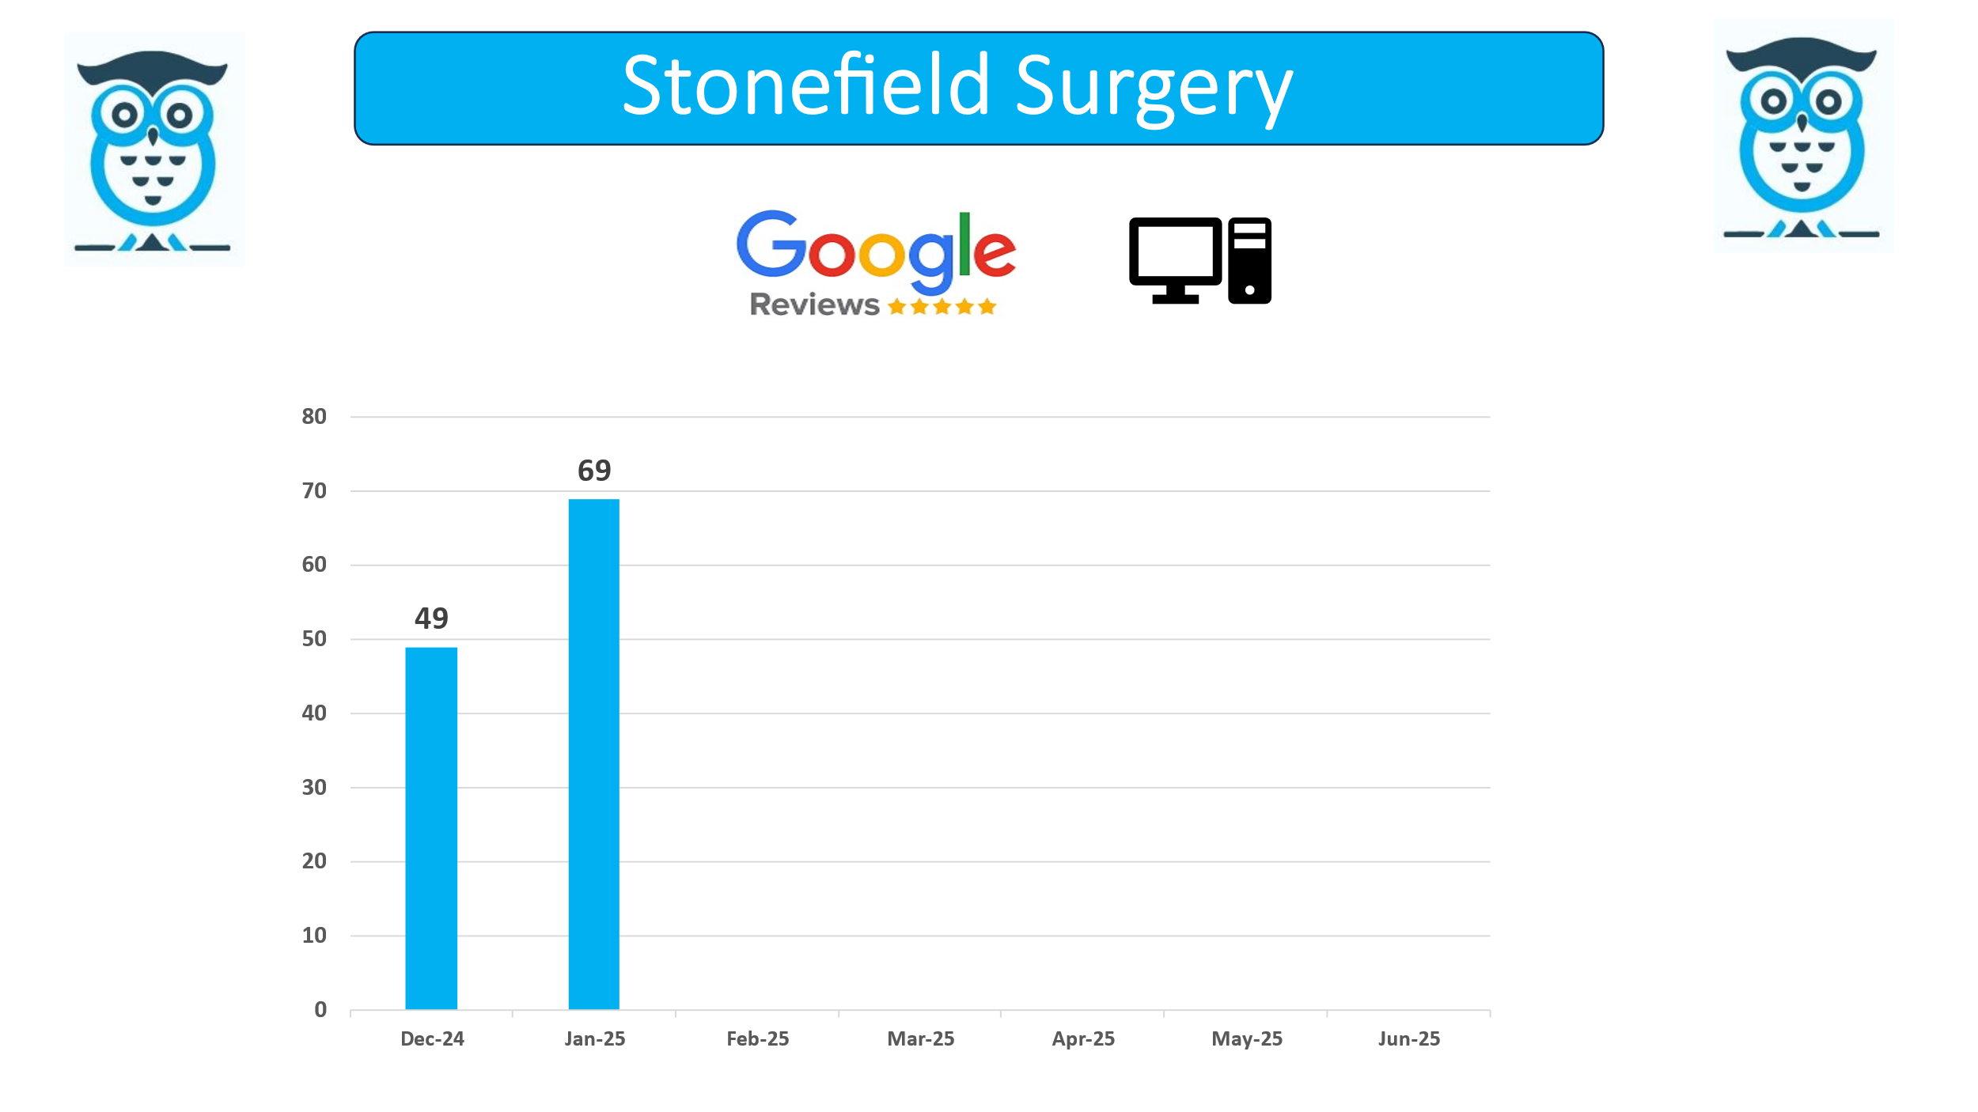  We are working together with Primary Care Growth Strategies to improve our rating for Google reviews. Since working with them, our reviews have massively increased in the last couple of months with us receiving 125 mostly 5* reviews.  We are aiming to achieve the strapline:  ‘Stonefield’s reputation is the best surgery in Rochdale’. | Fact
6 | Healthwatch  Karen expressed an interest in Healthwatch, addressing important issues for our young people and forming productive relationships in the wider community.  Healthwatch runs a Youthwatch that might be a good resource for us.  https://www.nhsglos.nhs.uk/news/students-share-valuable-insights-into-young-peoples-mental-health-wellbeing-with-surgery-team/ | All
7 | Topic of the Month  5 areas to be discussed at the next meeting:  - Patient Voice – Recruitment for PPG members  - Collaboration  - Local H&SC service awareness  - Patient information – what matters to you.  - Feedback (you said, we did)
8 | A.O.B  - On-site Pharmacy (Rowlands) plans are going ahead for scheduled opening on 3/3/25.  - Chairman thanked the members who assisted at the Womens Health Day event on 18th January. Much appreciated for your support.  - Patient sent in request for a wooden bench to have seating near the front door to rest whilst waiting for taxis or to be picked up. We have now put seating there as requested and informed the patient.  - Bird Boxes – Pleased to announce that we have witnessed some of the bird boxes have been having feathered visitors checking out the tenancy! Here is the proof! Thanks to Barry Sanderson for producing the boxes.  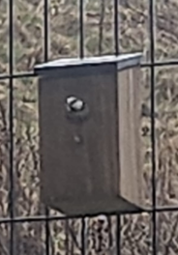 | Fact

2025 Meeting Dates / 4.30pm
Wednesday 12 February
Wednesday 16 April
Wednesday 18 June
Wednesday 13 August
Wednesday 15 October
Wednesday 17 December

